Safeguarding Policy

**Date developed:** February 2013

**Last review:** 3rd January 2023

**Next review:** January 2024

**Policy Holder:** Georgina Sexton – Centre Director

1. **Purpose:**

This policy outlines the framework and procedures to be carried out to safeguard young people, adults at risk of harm /vulnerable adults and those at risk of radicalisation at Qualified Education Ltd (referred to in this document as QE, we, us, the company) who also trades as ‘The Active Academy’.

1. **Scope** 
   1. Safeguarding refers to the process of protecting children (and adults) to provide safe and effective care. This includes all procedures designed to prevent harm to a child or adult. Safeguarding is a term that covers all people on site and at sub-contractor premises, e.g. staff, students, visitors, contractors, etc.
   2. Throughout the policy and supporting documentation, reference is made to ‘children’. That is, those under the age of 18. Qualified Education Ltd recognises that some adults are also vulnerable to abuse, therefore the procedures may be applied (with appropriate adaptions) when there are allegations of abuse of an adult. Some adults are more vulnerable to abuse because of their care and support needs as defined in The Care Act (2014).
   3. See Appendix 1 for key definitions of Children, Adults with Care and Support Needs (also referred to as adults at risk of harm) and Vulnerable Adults.
   4. Legislation underpinning the policy is outlined in Appendix 2
   5. Appendix 3 outlines indicators of abuse (as described in Keeping children safe in education 2022)
2. Policy Statement

QE aims to maintain a safe and welcoming environment for all students, staff and visitors. It is committed to meeting its statutory duties to safeguard and promote the welfare of children and adults at risk of harm. QE recognises its role in identifying cases of suspected abuse and making referrals to the appropriate investigating agencies. QE will work in partnership with statutory services to support students to be safe.

1. Policy This policy represents Qualified Education Ltd’s response to its role in safeguarding the welfare of students.
   1. QE will set up clear procedures with designated members of staff in charge of these procedures. QE will have an assigned safeguarding lead who will ensure procedures are followed.
   2. QE will work in partnership with other agencies (including the Police, Local Authorities and Clinical Commissioning groups) to support children and adults at risk of harm to stay safe and to investigate allegations of abuse.
   3. QE will ensure the student’s wishes or feelings are taken into account when determining what action to take and what services to provide to protect them.
   4. QE recognises that there are times when the wishes of the individual may be overruled if there is a significant risk of harm to a child or adult.
   5. QE will ensure that all staff, as part of staff development (including staff working for contracted out services) receive appropriate training to ensure that they are able to recognise the signs and symptoms of abuse. In addition, all staff will be made fully aware of the procedures for reporting and recording their concerns. QE will deliver training on radicalisation and the action that must be taken if there is a concern that someone may be drawn into terrorism.
   6. QE will monitor and review annually the Safeguarding Policy and Procedures as part of its equality initiatives.
   7. QE will ensure that all recruitment checks, as outlined in Keeping children safe in education (September 2022) are carried out.
   8. QE will recommend and disseminate its “Code of Conduct” for staff working with young people and vulnerable adults for all staff as outlined in guidance published by Government Offices for the English region.
2. Local and National Safeguarding Priorities

Qualified Education Ltd is mindful of its responsibilities to respond to current local and national priorities

5.1 Key areas Safeguarding issues include:

• Greater emphasis on emotional wellbeing and mental health

• Child Sexual Exploitation (CSE) and Child Criminal Exploitation

• **Child on child abuse:** All staff should be aware that children can abuse other children. All staff must challenge inappropriate behaviours between peers and not downplay sexual harassment as ‘banter, this is likely to include, but may not be limited to: - bullying (including cyberbullying)

- physical abuse

- sexual violence

- sexual harassment

- upskirting

- sexting

- initiation/hazing type violence and rituals

• Serious Violence. All staff should be aware of the indicators, which may signal that children are at risk from, or are involved in serious violent crime.

• All staff should be aware of the range of risk factors which increase the likelihood of involvement in serious violence, such as being male, having been frequently absent or permanently excluded from school, having experienced child maltreatment and having been involved in offending, such as theft or robbery

• Female genital mutilation. There is a specific legal duty on teachers to report to the police that an act of GFM appears to have been carried out on a girl under the age of 18.

• Contextualising safeguarding. Safeguarding incidents and/or behaviours can be associated with outside factors. All staff should consider the context within which such incidents/behaviours occur (i.e. are wider environmental factors present in a child’s life a threat to their safety and/or well-being).

1. Monitoring and Review
   1. Implementation of this policy is monitored through regularly and reviewed at the end of each year by the Designated Safeguarding Lead.
2. Safeguarding Procedures
   1. If any member of staff suspects that a young person or vulnerable adult is being abused they must share their concerns with the Designated Safeguarding Lead (DSL). The DSL will follow guidance and procedures identified in Keeping Children Safe in Education (2022) and Working Together to Keep Children Safe (2018), when deciding the action that needs to be taken.

“If at any point there is a risk of immediate serious harm to a child a referral should be made to Children’s Social Care immediately. Anybody can make a referral.” Details of all referrals must be shared with the relevant designated safeguarding team.

All concerns must be logged. Concerns will be followed up by the DSL.

* 1. All complaints, allegations or suspicions must be taken seriously. Absolute promises of confidentially should not be given as the matter may develop in such a way that these might not be able to be honoured. Victims of sexual harassment should be taken seriously, kept safe and never made to feel like they are creating a problem for reporting abuse, sexual violence or sexual harassment
  2. If the complaint comes directly from the child/adult, questions should be kept to the minimum necessary to understand what is being alleged and care is taken to avoid leading questions. Unnecessary questioning could jeopardise future legal proceedings.
  3. If it is deemed necessary for a safeguarding concern involving a student to be referred to statutory services, this must be done promptly and to the relevant authority.
  4. Information shared with the DSL will be kept securely in accordance with GDPR Guidelines. Safeguarding concerns relating to a child (under 18yrs) or a Vulnerable Adult will be held for 7 years after school leaving age. (For a child this will be until they are aged 26).

1. **Procedure for Allegations Against Staff** 
   1. Allegations of abuse against a member of staff, volunteers and contractors must be referred to the DSL as soon as possible and in any case within 2 hours of the initial concern arising. If the nominated member of staff cannot be contacted the Qualifications Manager must be contacted. The Centre Director should be notified and will follow the company disciplinary procedures. The DSL will inform the Local Authority Designated Officer (LADO) of any allegations that might indicate a person would pose a risk of harm to children.
   2. All allegations and investigations against members of staff will be conducted in line with legislation and good practice outlined in the revised statutory guidance “Keeping children safe in education.”
   3. In response to revised guidance (KCSIE 2022), QE will take appropriate action if a member of staff has displayed behaviour which may indicate a person poses, or may pose, a risk of harm, if they continue to work in regular or close contact with children. This is commonly known as the “harm test”. It can be applied to behaviours/incidents that occur outside the learning environment, and did not involve children but could have an impact on their suitability to work with children or vulnerable adults. Where a concern is regarded as ‘low level’ (KCSIE 2022) the Staff Code of Conduct will be implemented.
   4. When conducting an investigation involving a safeguarding issue (where the alleged victim is under 18 or a vulnerable adult) the investigating officer must take guidance from the DSL in relation to the interviewing procedure to be followed.
   5. The DSL may decide to stop proceedings and refer the case to the police for further investigation where this is deemed necessary.
   6. If a member of staff is dismissed or removed from “regulated activity” (or would have been had they not already left) because they harmed or posed a risk of harm to vulnerable groups including children, Qualified Education Ltd will be under a legal obligation to forward information about that person to the DBS. It is the responsibility of the DBS to make a decision on the barring or not of any individual. The member of staff may make representation to the DBS against being barred.
2. Procedures for Sexual Abuse
   1. In response to the Ofsted Review of Sexual Abuse in Schools and Colleges (June, 2021), existing procedures for addressing sexual abuse and harassment among students, including online sexual abuse have been amended.
   2. **Student guidance and support:** All students will receive a safeguarding briefing during Induction and Safeguarding will be monitored during reviews. The induction will be:

• delivered by designated staff,

• will signpost internal and external support,

• will empower students with information about how to identify, report, and cope with incidents of sexual abuse and harassment.

* 1. **Training for staff:** All staff receive mandatory training as part of their induction, to ensure they are aware of their safeguarding responsibilities and of the college’s policies and procedures. The training includes recognising signs of abuse, and recording and reporting suspected abuse. They receive updates on safeguarding and child protection at least annually. All staff are made aware of our duties under the Prevent agenda. All staff are required to read of Keeping Children Safe in Education (2022) Part One. All staff should be familiar with ‘What to do if you are worried a child is being abused’.

1. **Supporting Documentation**
   1. The following College documents give further guidance on the application of this policy and matters relating to the wider child protection agenda:

• Children Act 1989 and 2004

• Education Act 2002 (s175)

• Guidance for Safer Working Practice for Adults who Work with Children and Young People in Education Settings (2009)

• Keeping Children Safe in Education (2022)

• Prevent Duty Guidance (2015)

• Procedure for Visiting Speakers and Events

• Staff and Student Disciplinary Procedures •

What to do if you are worried a child is being abused (2015) • Working Together to Safeguard Children (2018)

• Staff Handbook

**Appendix 1 - Key Definitions**

1. **Children** - Children includes everyone under the age of 18 Any child may benefit from early help, but all staff should be particularly alert to the potential need for help for a child who:

• Is disabled and has specific needs

• Has special educational needs (whether or not they have an EHCP)

• Is a young carer

• Is showing signs of being drawn in to anti-social or criminal behaviour, including gang involvement and association with organised crime groups

• Is frequently/goes missing from care or from home

• Is at risk of modern slavery, trafficking or exploitation

• Is at risk of being radicalised or exploited

• Is in family circumstances presenting challenges for the child, such as drug and alcohol misuse, adult mental health issues and domestic abuse

• Is misusing drugs or alcohol themselves

• Has returned home to their family from care

• Is privately fostered • Is in the care of the local authority •

Is lesbian, gay, bi or trans

1. **Adults with Care and Support Needs** An adult with care and support needs may be:

• an older person

• a person with a physical disability, a learning disability or a sensory impairment

• someone with mental health needs, including dementia or a personality disorder • a person with a long-term health condition

• someone who misuses substances or alcohol to the extent that it affects their ability to manage day to day living

• victims of sexual exploitation

1. **Vulnerable Adult** - Current NHS definition of a Vulnerable Adult is:

A vulnerable adult is aged 18 or over, receives or may need community care services because of a disability, age or illness, and who is or may be unable to take care of themselves or protect themselves against significant harm or exploitation.

From September 2012, a vulnerable adult is defined by the Protection of Freedoms Act 2012 as a person aged 18 or over who is in receipt of regulated activity. This definition informs the level of DBS check required of people who provide support for adults.

1. **Regulated Activity (applies to children and vulnerable adults)** The term Regulated Activity is a statutory term used to describe working or volunteering with children or vulnerable adults. Regulated activity covers anyone working closely with children or vulnerable adults, either paid or unpaid, not part of a family or personal arrangement, on a frequent, intensive or overnight basis.

Frequent means once a week or more (except in health or personal care services where frequent means once a month or more); intensive means four times in a month or overnight.

**Appendix 2- legislation that underpins safeguarding policies and procedures.**

1. **“Keeping children safe in education”** Statutory guidance for schools and colleges, (September 2022)
2. This guidance replaces all previous versions of the document. This document contains information on what schools and colleges should do and sets out the legal duties with which schools and colleges must comply. The guidance stresses the need for effective and timely multi- agency action which promotes the best interest of the child.

The guidance should be read alongside Working Together to Safeguard Children (April 2018) and What to do if you are Worried a Child is Being Abused- Advice for Practitioners (March 2015)

1. The revised guidelines make reference to “Safeguarding and promoting welfare of children.” Safeguarding and promoting the welfare of children is defined as “protecting children from mal-treatment; preventing impairment of children’s health or development; ensuring that children grow up in circumstances consistent with the provision of safe and effective care; and taking action to enable all children to have the best outcomes”
2. The guidance states “Where a child is suffering significant harm, or is likely to do so, action should be taken to protect the child. Action should also be taken to promote the welfare of a child in need of additional support, even if they are not suffering harm or at immediate risk”
3. Legislation that underpins “Keeping children safe in education” Statutory guidance for schools and colleges that applies directly to education includes:

- Education and Training (Welfare of Children) Act 2021

- The Rehabilitation of Offenders Act 1974

- The Children Act 1989 and 2004

- The Education Act 2011

- The Further Education (Providers of Education) regulations 2006

- Safeguarding Vulnerable Groups Act 2006

- The Equality Act 2010

- The Protection of Freedoms Act 2012

- Children and Families Act 2014

- Counter Terrorism and Security Act 2015

- Prevent Duty Guidance (2015)

- Female Genital Mutilation Act 2003 (Serious Crime Act 2015)

1. **The Care Act.2014**. In the context of the legislation, specific adult safeguarding duties apply to an adult who:

• has care and support needs and

• is experiencing, or is at risk of, abuse or neglect and

• is unable to protect themselves because of their care and support needs

The Care Act 2014 explicitly requires local authorities to work with partner organisations, to actively promote people’s independence and well-being, not just to respond to crises when they occur. People with care and support needs are not inherently vulnerable, but they may come to be at risk of abuse or neglect at any point due to:

− Physical or mental ill health

− Becoming disabled

− Getting older

− Not having support networks

− Inappropriate accommodation

− Financial circumstances

− Being socially isolated

Legislation and Guidance which underpins safeguarding of vulnerable adults includes:

- Health Act (1999) includes provision for the protection of vulnerable adults

- No Secrets (2000)

- Care Standards Act (2000)

- Sexual Offences Act (2003)

- Mental Capacity Act 2005

- Safeguarding Vulnerable Groups Act (2006)

- Care Act 2014

- Children and Families Act 2014

- Counter Terrorism and Security Act 2015 Prevent Duty Guidance

1. The purpose of the **Safeguarding Vulnerable Groups Act (2006)** as amended by the **Protection of Freedom Act 2012** is to restrict contact between children and vulnerable adults and those who might do them harm. The level of DBS check required and whether a prohibition check is required will depend on the roles and duties of staff in an institution.
2. **The Counter-Terrorism and Security Act (2015)** places a public sector duty on Colleges to have due regard to the need to prevent people from being drawn into terrorism. The Prevent-related responsibilities includes helping prevent people being drawn into terrorism. This includes not just violent extremism but also non-violent extremism, which can create an atmosphere conducive to terrorism and can popularise views which terrorists exploit.
3. Section 5B of the **Female Mutilation Act 2003** (as inserted by section 74 of the Serious Crime Act 2015) places a statutory duty on teachers along with other professionals, where they discover (either through disclosure by the victim or through visual evidence) that FGM appears to have been carried out on a girl under 18.

**Appendix 3.**

**Indicators of abuse and neglect (taken from keeping Children safe in education 2022)**

All staff members should be aware that abuse, neglect and safeguarding issues are rarely standalone events that can be covered by one definition or label. In most cases, multiple issues will overlap with one another.

**Physical Abuse** Physical abuse may involve hitting, shaking, throwing, poisoning, burning or scalding, drowning, suffocation or otherwise causing physical harm to a child. Physical harm may also be caused when a parent or carer feigns the symptoms of or deliberately causes ill health to a child whom they are looking after.

**Emotional Abuse**

*Emotional abuse* is the persistent emotional ill-treatment of a child such as to cause severe and persistent adverse effects on a child's emotional development. It may involve conveying to children that they are worthless or unloved, inadequate, or valued only insofar as they meet the needs of another person. It may feature age or developmentally inappropriate expectations being imposed on children. It may involve causing children to feel frightened or in danger, or the exploitation or corruption of children. Some level of emotional abuse is involved in all types of ill-treatment of a child, although it may occur alone.

Types of emotional abuse include:

**Bullying:** Bullying is the oppression or persecution of a weaker person by a stronger person. It is sometimes included as a type of child abuse. The difference is that bullying is often inflicted by a peer rather than by an adult. However, adults and older children are capable of bullying behaviour and it is frequently an element of all types of child abuse.

**Cyberbullying:** Cyberbullying is the use of Information Communications Technology (ICT), particularly mobile phones and the internet, deliberately to upset someone. It is different from other forms of bullying because: it can take place at any time and can intrude into spaces that have previously been regarded as safe or personal; the audience can be very large and reached rapidly. Cyberbullying can take place between peers and across generations and some instances of cyberbullying are known to be unintentional.

**Sexual Abuse**

*Sexual abuse* involves forcing or enticing a child or young person to take part in sexual activities, whether or not the child is fully aware of what is happening. The activities may involve physical contact, including penetrative (e.g. rape or buggery) or non-penetrative acts. This may include non-contact activities, such as involving children in looking at or in the production of, pornographic material or watching sexual activities, or encouraging children to behave in sexually inappropriate ways.

The DfE’s definition of ‘child-on-child’ sexual abuse includes:

• Sexual violence, such as rape, assault by penetration and sexual assault

• Sexual harassment, such as sexual comments, remarks, jokes and online sexual harassment, which may be stand-alone or part of a broader pattern of abuse

• Sexting (see below)

• Upskirting (see below)

**Sexting:** Sexting (also known as ‘youth-produced sexual imagery’) is when someone sends or receives a sexually explicit text, image or video including consensual and non-consensual sharing of nude and semi-nude images and videos on their mobile phone, usually in a text message.

**Upskirting:** Upskirting typically involves someone taking a picture under a person’s clothing without them knowing, with the intention of viewing their genitals or buttocks to obtain sexual gratification, or to cause the victim humiliation, distress or alarm.

**Grooming** is the term used to describe how an adult gets to know a child gradually and in quite natural ways, with the intention of sexually abusing and /or exploiting them. With increased internet usage more children are being targeted for this form of abuse.

Many of these activities and behaviours are now conducted online. Typical platforms include WhatsApp and Snapchat.

This includes:

• Receiving unsolicited explicit photographs or videos, for example ‘dick pics’

• Sending, or being pressured to send, nude and semi-nude photographs or videos (‘nudes’)

• Being sent or shown solicited or unsolicited online explicit material, such as pornographic videos

**Neglect**

*Neglect* is the persistent failure to meet a child's basic physical and/or psychological needs, likely to result in the serious impairment of the child's health or development. It may involve a parent or carer failing to provide adequate food or shelter and clothing, failing to protect a child from physical harm or danger, or the failure to ensure access to appropriate medical care or treatment. It may also include neglect of, or unresponsiveness to, basic emotional needs.

**Specific safeguarding issues identified in Keeping children safe in education (September 2022)**

**Mental Health**

All staff should be aware that mental health problems can, in some cases, be an indicator that a child has suffered or is at risk of suffering abuse, neglect or exploitation. Where children have suffered abuse and neglect, or other potentially traumatic adverse childhood experiences, this can have a lasting impact throughout childhood, adolescence and into adulthood. It is important that all staff are aware of how these children’s experiences, can impact on their mental health, behaviour and education.

If staff have a mental health concern about a child that is also a safeguarding concern, immediate action should be taken, following the child protection policies.

**Child on child abuse**

• Bullying (including cyber bullying)

• Physical abuse

• Sexual violence and sexual harassment between children in schools and Colleges Sexual violence and sexual harassment can occur between two children of any age and sex. It can also occur through a group of children sexually assaulting or sexually harassing a single child or group of children,

• Sexting

• Initiation/hazing type violence and rituals

• Young people are sometimes required to give evidence in criminal courts, the Ministry of Justice has launched an online child arrangements too to support people going through the process.

**Children missing from education**

Children going missing from education can act as a warning sign of safeguarding possibilities. This may include abuse, neglect, child sexual exploitation, child criminal exploitation. It may indicate mental health problems, risk of substance abuse, risk of travelling to conflict zones, risk of FGM or forced marriage.

**Children with family members in prison**

Children with family members in prison are at risk of poor outcomes including poverty, stigma, isolation and poor mental health

**Child Sexual Exploitation (CSE) and Child Criminal Exploitation (CCE)**

Both CSE and CCE are forms of abuse and both occur where an individual or group takes advantage of an imbalance in power to coerce, manipulate or deceive a child (or vulnerable adult) into sexual or criminal activity. While age may be the most obvious, this power imbalance can also be due to a range of other factors including gender, sexual identity, cognitive ability, physical strength, status and access to economic or other resources. The abuse can be perpetrated by individuals or groups, males or females, and children or adults. The abuse can be a one-off occurrence or a series of incidents over time and range from opportunistic to t complex organised abuse. Victims can be exploited even when activity appears consensual, and exploitation as well as being physical can be facilitated and/or take place on-line

**Domestic abuse**

Any incident or pattern of incidents of controlling, coercive, threatening behaviour, violence or abuse between those aged 16 or over who are, or have been intimate partners or family members. Children can be victims of domestic abuse. They may see, hear, or experience the effects of abuse at home and/or suffer domestic abuse in their own intimate relationships (teenage relationship abuse).

**Homelessness**

Being homeless or at risk of becoming homeless presents a real risk to a child’s welfare. It is important to recognise that some 16 and 17 year old young people could be living independently from their parent/guardian and will require a different level of intervention and support

**So called “honour-based crime”**

So called “honour based violence (HBV) encompasses incidents or crimes which have been committed to protect or defend the honour of the family and/or community, including FGM,, physical abuse and forced marriage Female Genital Mutilation (FGM) FGM comprises all procedures involving partial or total removal of female genitalia or other injury to female genital organs.

Section 5B of the FGM Act 2003, places a statutory duty upon teachers to report to the police where they report to the police where they discover that FGM appears to have been carried out on a girl under 18.

**Forced marriage**

A forced marriage is a crime in England and wales. A forced marriage is one entered into without the full and free consent of one or both parties and where violence, threats or any form of coercion is used to cause a person to enter into a marriage.

**Preventing radicalisation**

Schools and Colleges have a responsibility to protect vulnerable people from extremist ideology and intervene to prevent those at risk of radicalisation being radicalised. All schools and colleges are subject to a duty under Section 26 of the counter-terrorism and Security Act 2015 in the exercise of their functions to have “due regard to the need to prevent people from being drawn into terrorism”.

The Prevent duty is an integral part of the College’s safeguarding obligations. (see Appendix 4 for Prevent/Channel processes)

**Terrorism**

Defined in the Act as ‘The use or threat of action designed to influence the government or an international governmental organisation or to intimidate the public or a section of the public; made for the purposes of advancing a political, religious, racial or ideological cause’

**Extremism**

Defined in the Prevent Strategy as ‘vocal or active opposition to fundamental British values, including democracy, the rule of law, individual liberty and mutual respect and tolerance of different faiths and beliefs’

**Radicalisation**

Defined as ‘the process by which a person comes to support terrorism and extremist ideologies associated with terrorist groups’.

**Abuse of position of trust**

Under the Sexual Offences Act 2003 it is an offence for a person over 18 e.g. teacher, to have a sexual relationship with a young person under 18 where that person is in a ‘position of trust’ in respect of the young person, even if the relationship is consensual.

**Vulnerable Adults – descriptions and categories of abuse (identified in Care and support statutory guidance 2015)**

**Physical Abuse:**

This includes hitting, slapping, pushing, kicking, rough handling or unnecessary physical force either deliberate or unintentional, misuse of medication, restraint or inappropriate sanctions.

**Sexual Exploitation:**

Sexual exploitation is the sexual abuse of children and vulnerable adults through the exchange of sex or sexual acts for drugs, food, shelter, protection, other basics of life, and/or money. Sexual exploitation includes involving children and vulnerable adults in creating pornography and sexually explicit websites.

**Psychological Abuse**:

This includes emotional abuse, threats of abandonment or harm, deprivation of contact, humiliation, blaming, controlling, intimidation, coercion, harassment, verbal abuse, isolation or withdrawal from services or supportive networks.

**Financial or Material Abuse**:

This includes theft, fraud, exploitation, pressure in connection with wills, property, enduring power of attorney, or inheritance or financial transactions, or the inappropriate use, misuse or misappropriation.

**Neglect and Acts of Omission:**

This includes ignoring or withholding medical or physical care needs, failure to provide access to appropriate health, social care or educational services, the withholding of the necessities of life, such as medication, adequate nutrition, clothing and heating.

**Discriminatory Abuse:**

including forms of: harassment, slurs or similar treatment because of:

• Race

• Gender and gender identity

• Age

• Disability

• Sexual orientation

• Religion

**Organisational Abuse:**

This is the mistreatment of a vulnerable adult by a regime or individuals in an institution. It can be through repeated acts of poor or inadequate care and neglect, or poor professional practice.

**Domestic Violence and Abuse:**

an incident or pattern of incidents of controlling, coercive, threatening behaviour, violence or abuse between those aged 16 or over who are, or have been, intimate partners or family members regardless of gender or sexuality.

The abuse can encompass, but is not limited to:

• Psychological

• Sexual

• Financial

• Emotional

• physical

**Modern slavery:** Includes slavery, human trafficking, forced labour and domestic servitude, traffickers and slave masters using whatever means they have at their disposal to coerce, deceive and force individuals into a life of abuse, servitude and inhumane treatment.

**Appendix 4**

**Information on REGULATED ACTIVITIES**

**A Regulated Activity** may be a role that is carried out frequently or intensively or overnight in any of the following **specified** settings:

* Schools (educational institutions exclusively or mainly for the provision of full time education to under-18s)
* Pupil referral units
* Childcare premises (including nurseries)
* Residential homes for children in care
* Children’s hospitals (hospitals exclusively or mainly for the reception and treatment of children)
* Children’s detention centres (institutions exclusively or mainly for the detention of children)
* Children’s centres in England and Wales, and
* Adult care homes (residential care or nursing homes in Northern Ireland).

Regulated activity can also include any of the following specified activities:

* Teaching, provided wholly or mainly for children and vulnerable adults
* Training, provided wholly or mainly for children or vulnerable adults
* Supervising
* Advice
* Treatment, or
* Transport

**To be eligible to request an Enhanced DBS check a position must meet both the definition of the activity and meet the frequency or intensive test**. It cannot be Regulated Activity if it does not meet both conditions.

For DBS purposes a vulnerable adult is a person who is aged 18 years or older and:

* is living in residential accommodation, such as a care home or a residential special school;
* is living in sheltered housing;
* is receiving domiciliary care in his or her own home;
* is receiving any form of health care;
* is detained in a prison, remand centre, young offender institution, secure training centre or attendance centre or under the powers of the Immigration and Asylum Act 1999;
* is in contact with probation services;
* is receiving a welfare service of a description to be prescribed in regulations;
* is receiving a service or participating in an activity which is specifically targeted at people with age-related needs, disabilities or prescribed physical or mental health conditions or expectant or nursing mothers living in residential care (age-related needs includes needs associated with frailty, illness, disability or mental capacity);
* is receiving direct payments from a local authority/HSS body in lieu of social care services;
* requires assistance in the conduct of his or her own affairs.

In order for eligibility to exist in this case the role must meet the eligibility criteria for Regulated Activity. This means working in the **same specified place**, working **frequently** (once a week or more) and **having the opportunity to have contact with children or vulnerable adults** or carrying out a **specified activity, frequently.** If this is the case then eligibility would exist.

**Appendix 5**

**Possible indicators of abuse of teenagers**

It can be harder to spot signs of abuse in teenagers than in younger children or vulnerable adults as teenagers are more capable of covering up injuries; however it is important that staff are aware of changes in a learner’s behaviour, attendance or attitude to their work as the changes could be indicators of abuse.

Possible indicators of abuse in teenagers

* Poor self esteem
* Depression and anxiety
* Tiredness due to sleep disturbance
* Not eating, weight loss or weight gain
* Marked changes in attendance at College, unexplained absences from college, lengthy absences from college
* Marked changes in behaviour, learners becoming withdrawn or aggressive
* Pregnancy
* STD

**Possible indicators of abuse of vulnerable adults**

Some Possible Indicators of physical abuse:

* unexplained skin bruising
* unexplained cuts or abrasions
* unexplained burns
* unexplained fractures etc

However, please remember some physiological processes/medical conditions can cause changes which are hard to distinguish from some aspects of physical abuse.

Some possible indicators of neglect:

* poor hygiene
* malnutrition
* inappropriate clothing
* broken skin

Some possible psychological and emotional indicators:

* withdrawal
* depression
* cowering and fearfulness
* sudden changes in behaviour
* deliberate self-harm

Some possible indicators of sexual abuse:

* unexplained marked fluctuation of mood changes
* urinary infection
* pain, bruising or bleeding in genital or anal areas
* inappropriate sexually related activities/behaviour

Some general indicators which may suggest abuse:

* seeking shelter or protection
* unexplained reactions towards particular settings
* frequent or regular visits to the GP, or hospital casualty department, or hospital admissions
* frequent or irrational refusal to accept investigations or treatments for routine difficulties
* inconsistency of explanation

The following "trigger" behaviours may be additional indicators that abuse is occurring:

* destruction of physical environment
* turning night into day/sleep disturbance
* chronic incontinence
* extreme physical and/or emotional dependence
* verbal abuse and aggression towards the carer
* changes in personality – caused by illness and/or medication
* noncompliance with carer’s wishes
* obsessive behaviour
* wandering/absconding
* self-harm

***Appendix 6***

**Additional Information on Cyberbullying**

|  |  |
| --- | --- |
| **Technology** | **Example of Misuse** |
| Mobile phones | Sending nasty calls or text messages, including threats. Intimidation or harassment. Taking and sharing humiliating images. Videoing other people being harassed and sending these to other phones or internet sites |
| What’s App  Snap Chat | Sending inappropriate messages or content. |
| Email | Sending inappropriate, nasty or threatening messages. Forwarding unsuitable content including images and video clips, or sending computer viruses. Accessing someone else’s account, e.g. to forward personal emails or delete emails. |
| Webcams | Making and sending inappropriate content. Persuading or threatening young people to act in inappropriate ways. Using inappropriate recordings to manipulate young people. |
| Social network sites e.g.  Facebook, Twitter, Instagram and  Internet dating sites (e.g. Tinder) | Posting nasty comments, humiliating images / video.  Accessing another person’s account details and sending unpleasant messages, deleting information or making private information public. Groups of people picking on individuals by excluding them. Creating fake profiles to pretend to be someone else, e.g. to bully, harass or get the person into trouble  Trolling (posting inflammatory, extraneous, or off-topic messages in an online community with the deliberate intent of provoking the account holder)  Vulnerable people may be exploited through relationships established on internet-dating sites |
| You tube | Posting embarrassing, humiliating film of someone. |
| Virtual Learning  Environments | Posting inappropriate messages or images. Hacking into someone else’s account to post inappropriate comments or delete schoolwork. |
| Gaming sites,  consoles and  virtual worlds | Name-calling, making abusive / derogatory remarks. Players may pick on weaker or less experienced users, repeatedly killing their characters.  Forwarding unwanted messages to other devices in the immediate vicinity. |
| Identity Theft | Bank details and other personal information being stolen and used inappropriately |

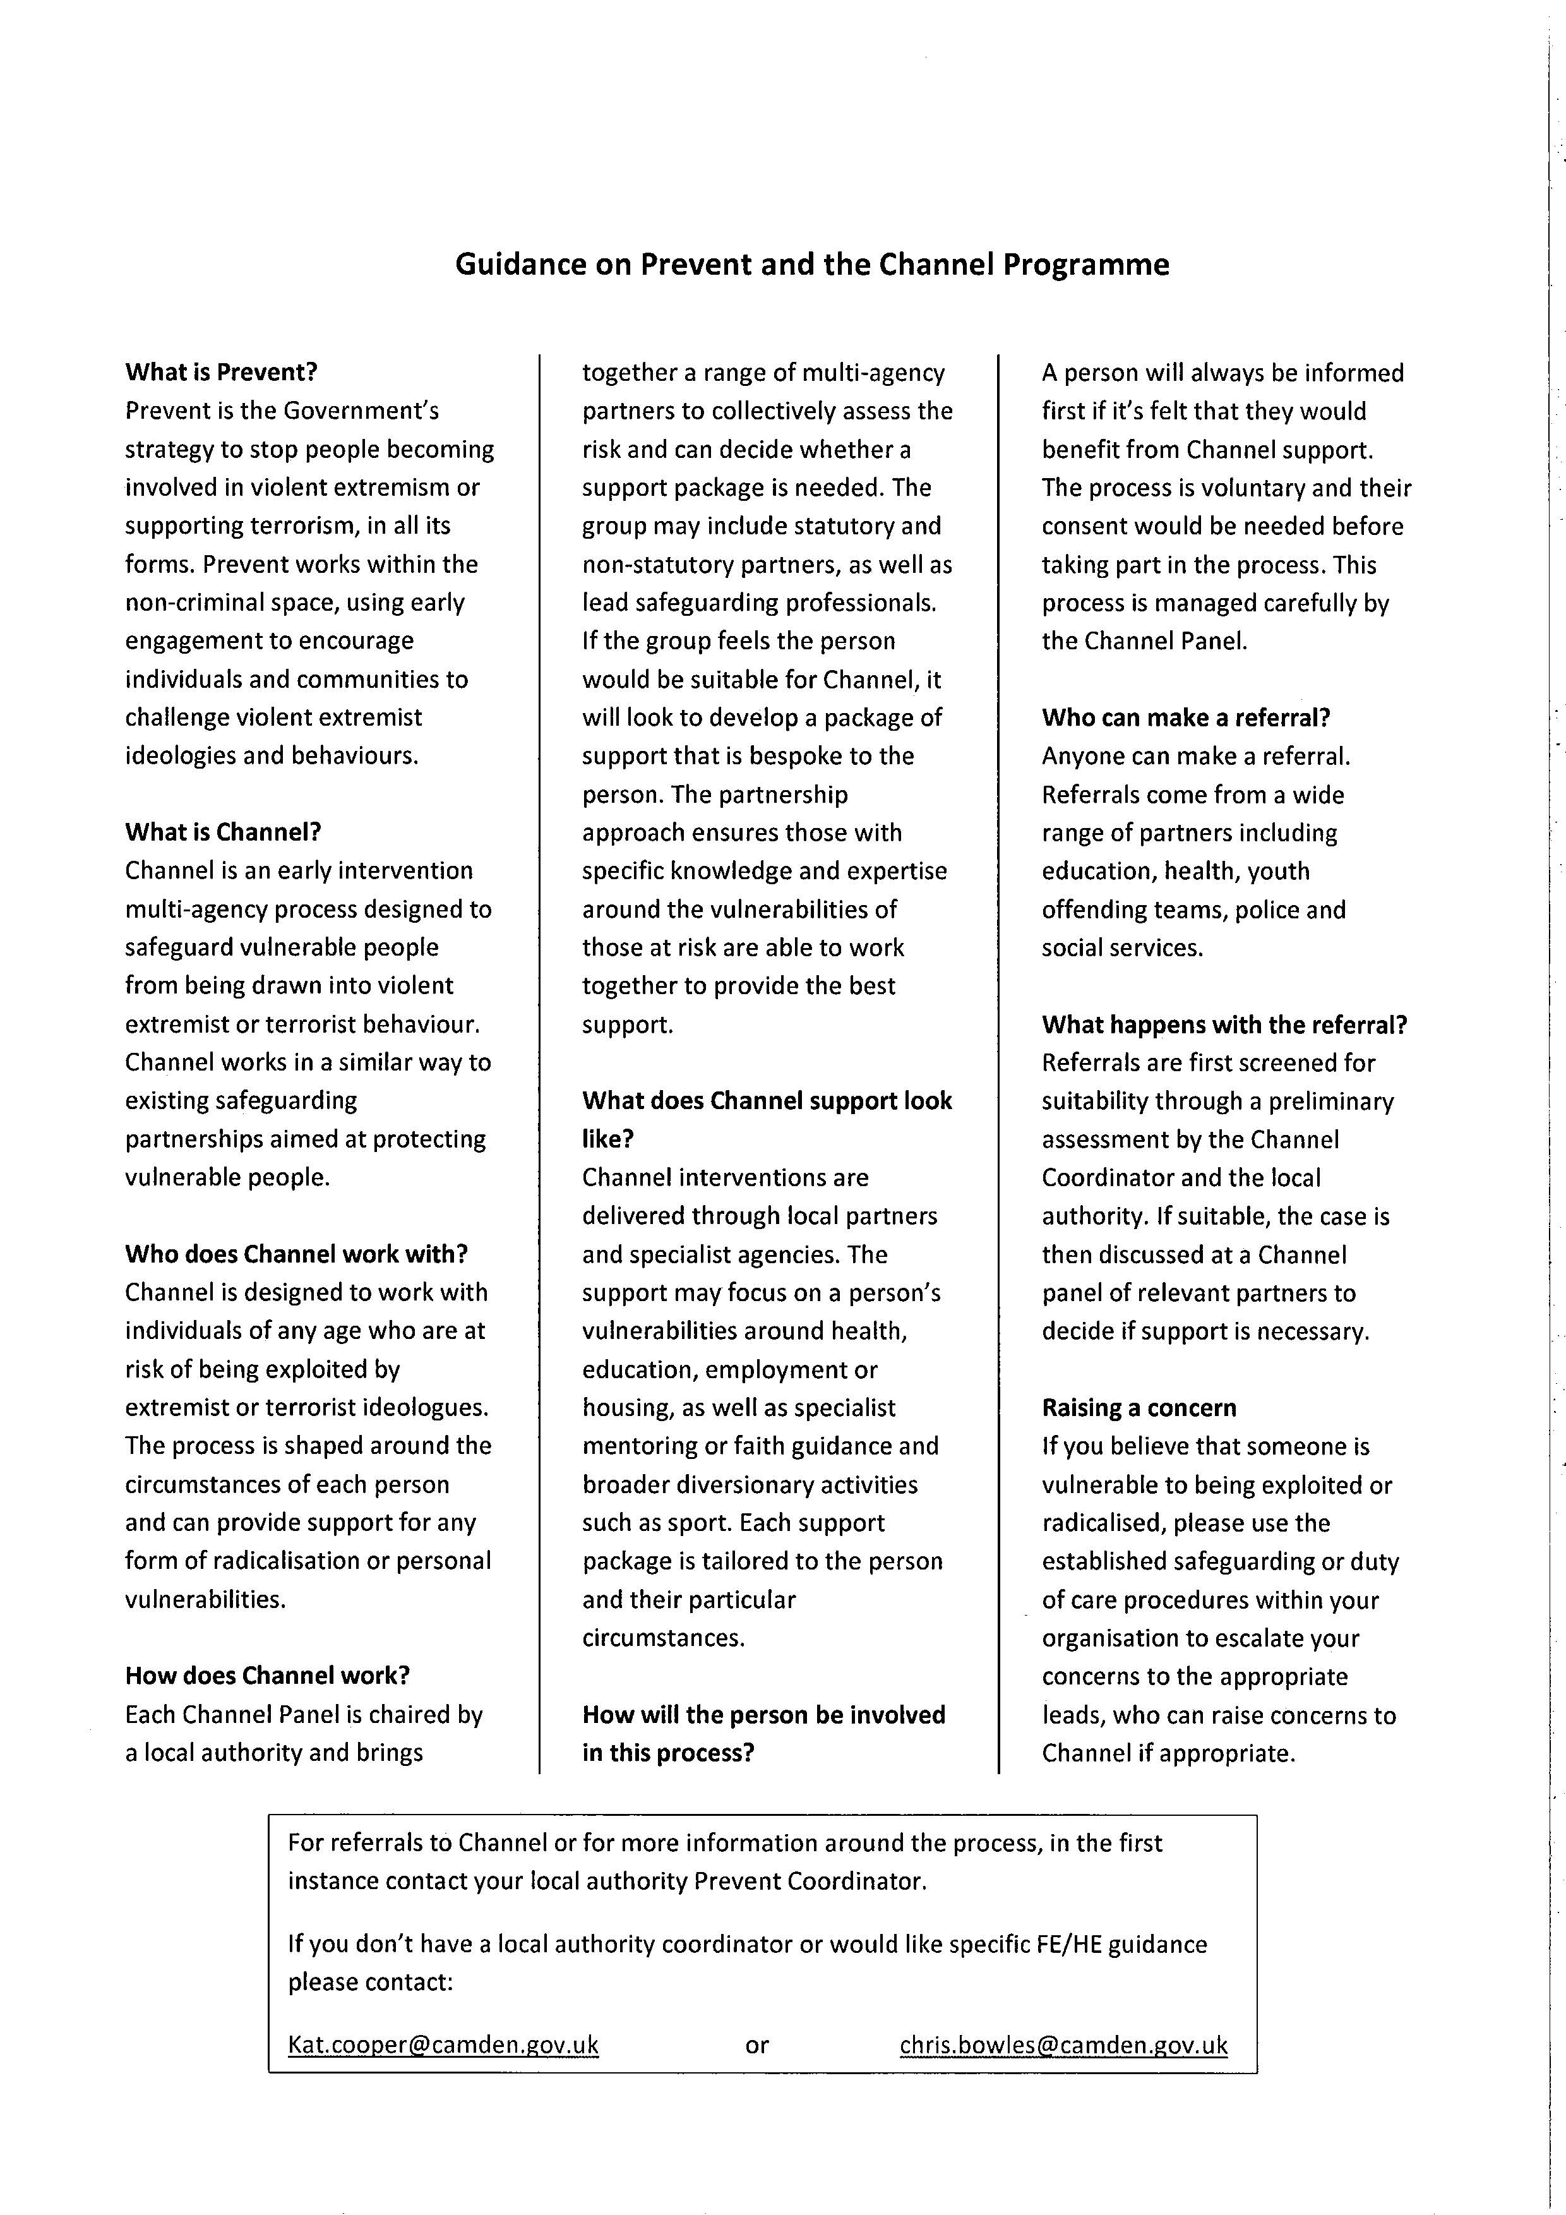

***Appendix 7***

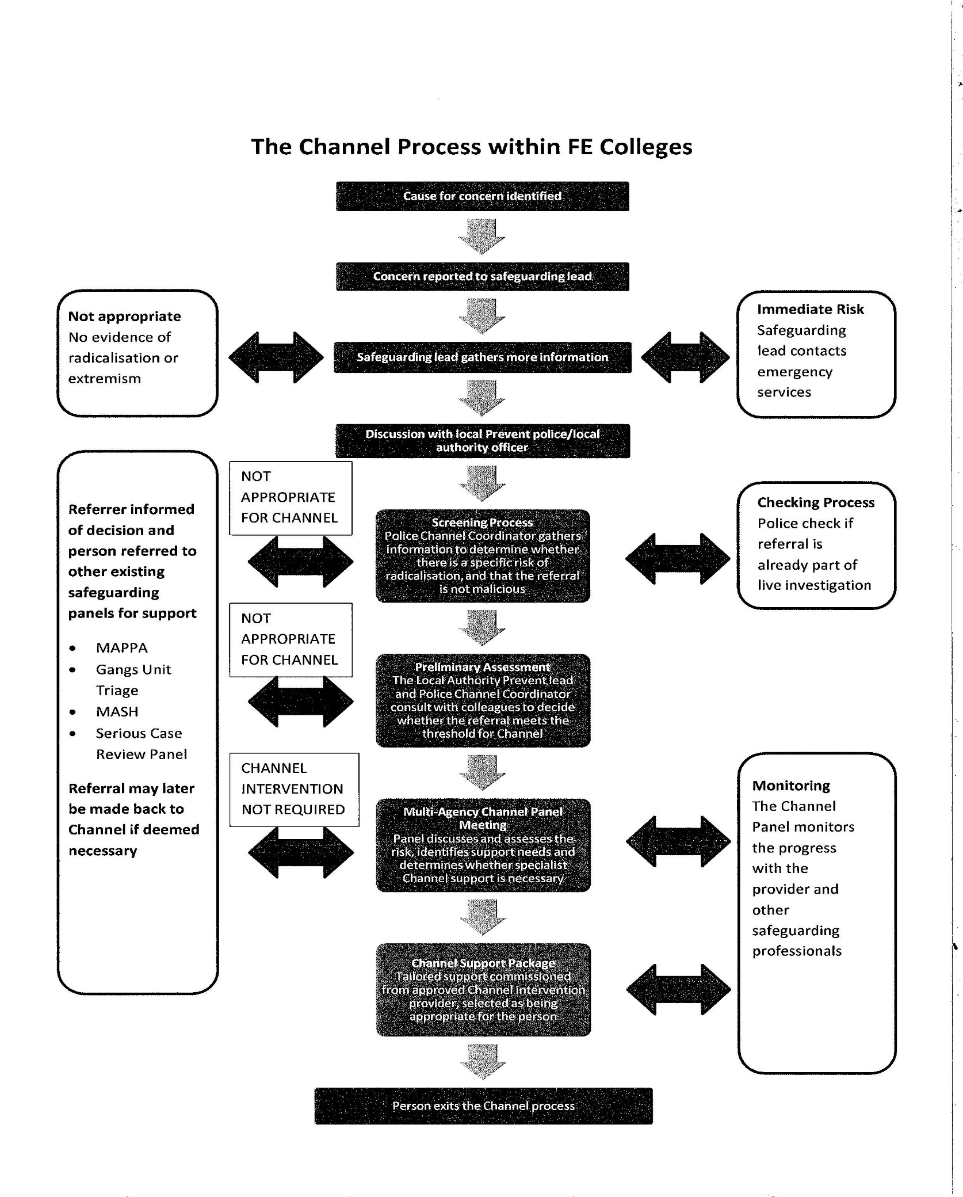

**Appendix 8**

**SAFEGUARDING: NOMINATED MEMBERS OF STAFF**

**WHAT TO DO IF A LEARNER DISCLOSES AN ISSUE INVOLVING ABUSE OR IF YOU HAVE A SAFEGUARDING CONCERN**

|  |  |  |
| --- | --- | --- |
| Learner discloses an issue involving abuse to member of staff or  Staff member has a safeguarding cause for concern | | |
|  |  |  |
| **Staff member is required to:**   * Inform Centre Director immediately, or at earliest opportunity. If the Centre Director is unavailable, please contact the Qualifications Manager. * Fill in the Safeguarding Concern Form and pass to the Centre Director or Designated Senior Person. Do not ask learner leading questions or ask for details.   **Acknowledge, listen, record and refer**   * Record conversation on concern form using exact words and contexts * Sign and date form and email to georgina@qualified-education.co.uk | | |
|  |  |  |
| **By doing the above you have fulfilled your obligations. You should not discuss the issue any further with the learner once the referral has been made** | | |
|  |  |  |

**Appendix 9**

**SAFEGUARDING CONCERN FORM**

To: ………………………………………………………….. Date of referral: ……………………………

From: …………………………………………………… Job title: ……………………………….……

Name of Learner: …………………………………………………………………………………………….

D.O.B: …………………………………… Course: ………………………………………………………..

Learners phone number: …………………………….. Tutor: ………………………………………...

Nature of Concern: …………………………………………………………………………………………..

…………………………………………………………………………………………………………………….

…………………………………………………………………………………………………………...............

……………………………………………………………………………………………………………………

Action Taken: …………………………………………………………………………………………………

…………………………………………………………………………………………………………..............

……………………………………………………………………………………………………………………

……………………………………………………………………………………………………………………

Agencies involved? If so give Name and Contact details: ………………………………………..

…………………………………………………………………………………………………………………..

…………………………………………………………………………………………………………………..

…………………………………………………………………………………………………………………..

Signed: ………………………………………………………. Dated: …………………………………….

**Appendix 10**

**INFORMATION FROM NORFOLK SAFEGUARDING ADULTS TEAM**

Your Safeguarding Adults Team who can be contacted for advice and information via Tel: **0344 800 8020**

* **Norfolk Safeguarding Adults Team Manager**

**Helen Thacker**

* **Multi-Agency Safeguarding Hub (MASH)**

**Wendy Masters, Safeguarding Adults Practice Consultant**

**Toby Thouless, Safeguarding Adults Practice Consultant**

* **Central Locality**

**Dee Blakey, Safeguarding Adults Practice Consultant**

**Useful Telephone Numbers**

|  |  |
| --- | --- |
| **Care Quality Commission** (CQC) | 03000 616161 |
| **Police:**   * Emergency * Non-Emergency | 999  101 |
| **MASH (**Multi-Agency Safeguarding Hub**)** | 0344 800 8020 |
| **Health:**   * Debbie Beresford – Safeguarding Adults Lead, Norfolk Community Health & Care * Dawn Collins, Safeguarding Adults Lead, Norfolk & Norwich University Hospital, Norwich * Howard Stanley– Safeguarding Adults Lead, Norfolk Clinical Commissioning Groups (CCG’s) * Gerry Green, Safeguarding Adults Lead, Queen Elizabeth Hospital, Kings Lynn * Julia Hunt – Chief Matron, James Paget Hospital, Gorleston * Walter Lloyd-Smith – Safeguarding Adults Lead, East Cost Community Health Care CIC * Jackie Schneider - Head of Quality & Patient Safety, North Norfolk Clinical Commission Group (CCG) | 01603 776776  01603 646028  01603 257030  Mob: 07939099002  01553 613613  01493 452452  01493 334113  01263 738100 |
| **NHS and Social Care Whistleblowing Helpline** | 08000 724725 |

|  |  |
| --- | --- |
| **Mental Health:**   * Saranna Burgess – Safeguarding Lead, Norfolk & Suffolk NHS Foundation Trust | 01603 421311 |
| **Quality Assurance:**   * Roger Morgan | 01603 223988 |
| **Domestic Violence:**   * Domestic Violence Unit, Norfolk Constabulary | 01603 276339 |
| **Hate Crime:**   * Emergency * Non-Emergency * Text * Refer via website – link below   <http://www.norfolk.gov.uk/Community_and_living/Equality_and_strong_communities/Hate_Free_Norfolk/index.htm> | 999  101  07786 200777 |
| **Other Authorities:**  Cambridgeshire   * Cambridgeshire Direct   Lincolnshire   * Lincolnshire Safeguarding Adults Team * Emergency Duty Team   Suffolk   * Suffolk Safeguarding Adults Team | 0345 0455202  01522 782155  01522 782333  0808 8004005 |

***Appendix 11***

**Referrers Checklist - Tel: 0344 800 8020**

This Checklist is to assist you to have adequate information when you are making a referral as we know that it is often a very stressful conversation and you may forget vital information when you make the call. Referrals will be considered when some of this information is not available.

|  |  |  |
| --- | --- | --- |
|  | **Essential** | **Desirable** |
| **Name of Alerter** (Youcan remain anonymous) |  |  |
| **Contact details of Alerter** |  |  |
| **Relationship to Victim** |  |  |
| **Organisation of Alerter** |  |  |
|  |  |  |
| **Name** (of Vulnerable Adult) |  |  |
| **Address of Vulnerable Adult** |  |  |
| **Address, if different, of place of alleged abuse** |  |  |
| **Contact details of Vulnerable Adult** |  |  |
| **Details of Category of Vulnerability** (Older, frail, Mental Health, Learning Difficulties etc.) |  |  |
| **Date of Birth or Age** |  |  |
| **Gender** |  |  |
| **Ethnicity** |  |  |
| **Religion** |  |  |
| **Capacity and understanding** |  |  |
| **Communication needs** (sensory loss, Language, other) |  |  |
| Name of Alleged Perpetrator |  |  |
| Address of Alleged Perpetrator |  |  |
| Date of Birth of Alleged Perpetrator |  |  |
|  |  |  |
| **Details of Referral -** You need to consider the following so that the person taking the referral can gain adequate information |  |  |
| **Nature of abuse/incident** |  |  |
| **When did it happen?** |  |  |
| **Where did it happen?** |  |  |
| **Was anyone else involved?** |  |  |
| **Was the incident witnessed?** |  |  |
| **Have you had previous concerns regarding this person? If so what?** |  |  |
| **Does the vulnerable adult know you are making this referral?** |  |  |
| **Have you done anything to assist the Vulnerable Adult at this time? (**What actions have been taken?) |  |  |
|  |  |  |
| **How do you want to be contacted in the future?** |  |  |

***Appendix 12***

**SAFEUGARDING ADULTS – WHAT TO RECORD**

**RECORDING TEMPLATE**

|  |  |  |  |
| --- | --- | --- | --- |
|  | **Detail** | **Date** | **Time** |
| Initial discussion with |  |  |  |
| Referral (if made) |  |  |  |
| Strategy discussion   * With whom |  |  |  |
| Action Required   * By whom |  |  |  |

***Appendix 13***

***Body Map***



* Injuries deemed to be serious, would be those more serious than:

Grazes, abrasions, minor bruising, reddening of the skin, superficial cuts etc.

**In any case where the circumstances dictate that the Police are notified**

**DO NOT DELAY – Evidence can be lost!**

Refer to Norfolk Adult Social Services 0344 800 8020

Yes

Ring 999

No

**Appendix 14**

**Useful Links**

Link to

* Norfolk Safeguarding Adults Policy
* Norfolk Safeguarding Adults Procedures
* Norfolk Safeguarding Adults Legislative Guidance

<http://www.norfolk.gov.uk/Adult_care/Keeping_safe/Safeguarding_adults/NCC115071>

Link to

* Useful Further Information
* Safeguarding Adults Leaflet
* Poster
* New Letters
* Reports

<http://www.norfolk.gov.uk/Adult_care/Keeping_safe/Safeguarding_adults/NCC115061>

Link to

* Disclosure and Barring Service guidance and referral form

<https://www.gov.uk/government/organisations/disclosure-and-barring-service>

Link to

* Hate crime in Norfolk

<http://www.norfolk.gov.uk/Community_and_living/Equality_and_strong_communities/Hate_Free_Norfolk/index.htm>